3: Technical Solution

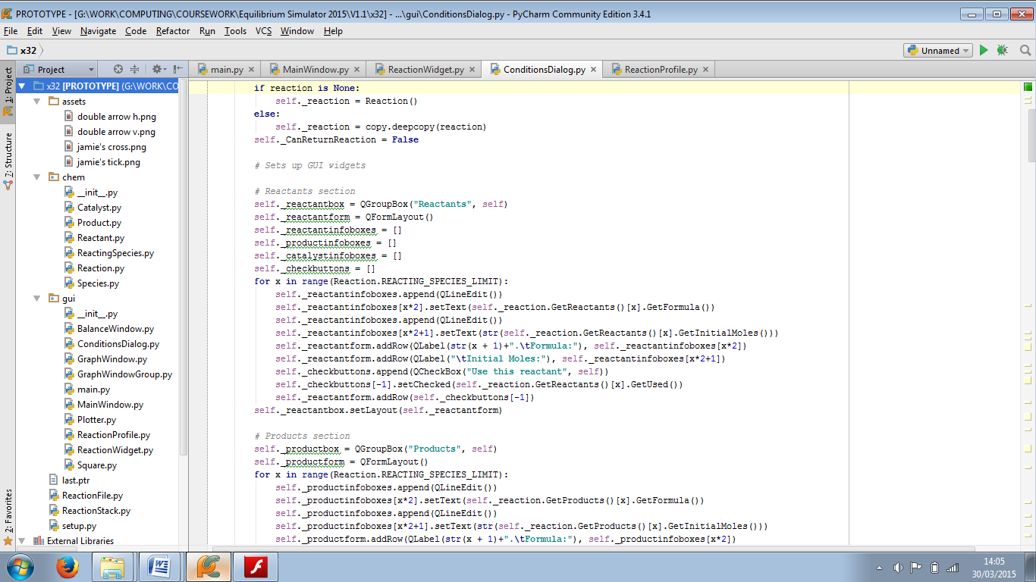The program’s source code and asset files are organised according to the file structure in figure 3.1.

The “assets” folder contains some image files to make the program more user-friendly. The “chem” package contains the classes that represent aspects of the reaction. The “gui” package contains all the classes that make up the program’s graphical user interface, as well as main.py (this is the first file to be run, and it starts the entire application). The __init__.py files are there to describe the folder to Python as a package that it can run code from.

Outside the folders are ReactionFile.py, which describes the structure of a reaction file, and ReactionStack.py, which provides stacks to hold alternate versions of reactions when the Undo or Redo functions are used. Also included is setup.py: the build script used to compile the program into a standalone binary application.

Item 11 of the Appendix consists of images of the program’s source code, and setup.py, at the time of distribution to the end user.

Figure 3.1: The program’s file and folder structure